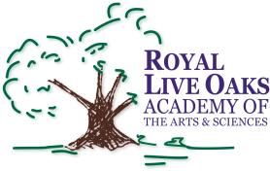 1398 Church Road, Hardeeville, SC 29927 • 843-784-2630 • www.rloacs.org

AGENDA

The Royal Live Oaks Academy of Arts & Sciences Charter School Special Board Meeting
August 27, 2015 6:00pm
Student Dining Hall

- Call to Order -- Vice-Chair

- Counting of Ballots for Board Seat -- Secretary

- Adjournment

