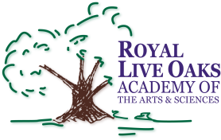
Royal Live Oaks Academy
2nd Grade Supply List
2016-2017

3 Composition notebooks (Primary)

5 Folders with brads & pockets (2red, 1 yellow, 1 blue and 1 green)

1 package of construction paper

2 boxes of crayons (24 counts)

2 dozens #2 pencils

2 large erasers

1 box of (pencil-topers) erasers

1 pair of scissors (pointed)

2 bottles of glue

1 (1 1/2in.)ring notebook

2 bottles of liquid hand soap & 2bottles of hand sanitizer (germ-x)

2 large boxes of Kleenex

1 gallon size Zip-lock bags

1 quart size of Zip-lock bags

1 roll of Bounty select- a- size papertowels

1 bottle of Clorox wipes

1 pair of ear buds for computer lab use

*Choose one from the following:

1 package of paper plates, 1 bottle ofgerm-x, one box of Kleenex or 1 bottle of Clorox wipes

