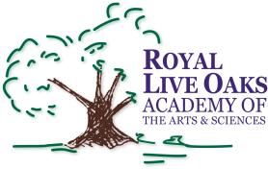 1398 Church Road, Hardeeville, SC 29927 • 843-784-2630 • www.rloacs.org

AGENDA

The Royal Live Oaks Academy of Arts & Sciences Charter School Board Meeting
February 16, 2016 6:30pm
Student Dining Hall

- Old business:

  - Approval of Minutes of January 19, 2016 meeting - Secretary

- New business:

  - RLOA Mission Statement - Chair

  - January Finance Report - Bill Moser, Kelly-Moser Consulting

  - Update on Two Modulars and on New Campus - Facilities Development Company

  - School Updates – Executive Director

- Public Comment

- Adjournment

