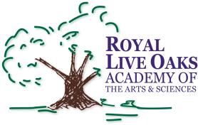 1398 Church Road, Hardeeville, SC 29927 • 843-784-2630 • www.rloacs.org

AGENDA

The Royal Live Oaks Academy of Arts & Sciences Charter School Board Meeting
March 21, 2017 6:30pm
Student Dining Hall

- Call to Order and Approval of Agenda

- Approval of February 21, 2017 Minutes - Secretary

- Public Comment

  - RLOA Mission Statement – Chair

  - February Finance Report - Bill Moser, Kelly-Moser Consulting

  - Update on New Campus Financing – Executive Director

  - Approvals: 2017-2018 Organizational Chart

  - School Updates – Executive Director

- Executive Session

- Adjournment

