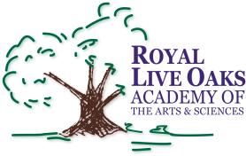 1398 Church Road, Hardeeville, SC 29927 • 843-784-2630 • www.rloacs.org

AGENDA

The Royal Live Oaks Academy of Arts & Sciences Charter School Board Meeting
May 19, 2015 6:30pm
Cafeteria

- Old business:

  - Approval of Minutes of April 21, 2015 meeting - Secretary

- New business:

  - RLOA Mission Statement - Chair

  - May Finance Report - Bill Moser, Kelly-Moser Consulting

  - 3rd Reading of 2015-16 Budget – Bill Moser, Kelly-Moser Consulting

  - Update on New Campus - Facilities Development Company

  - School Updates – Executive Director

  - Boys & Girls Club Proposal – Executive Director

- Public Comment

- Adjournment

