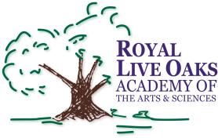 1398 Church Road, Hardeeville, SC 29927 • 843-784-2630 • www.rloacs.org

AGENDA

The Royal Live Oaks Academy of Arts & Sciences Charter School Board Meeting
June 16, 2015 6:30pm
Cafeteria

- Old business:

  - Approval of Minutes of May 19, 2015 meeting - Secretary

- New business:

  - RLOA Mission Statement - Chair

  - June Finance Report - Bill Moser, Kelly-Moser Consulting

  - 2015-16 Budget – Bill Moser, Kelly-Moser Consulting

  - Report on Meeting with District re School Performance Profile Financial Ratings - Bill Moser and Dr. Karen Wicks

  - Update on New Campus - Facilities Development Company

  - School Updates – Executive Director

  - Boys & Girls Club – Chris Protz

- Public Comment

- Adjournment

