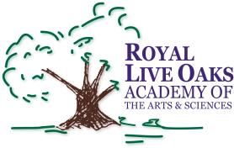 1398 Church Road, Hardeeville, SC 29927 • 843-784-2630 • www.rloacs.org

AGENDA

The Royal Live Oaks Academy of Arts & Sciences Charter School Board Meeting
January 20, 2015 6:30pm
Cafeteria

- Old business:

  - Approval of Minutes of November 18, 2014 meeting - Secretary

- New business:

  - RLOA Mission Statement - Chair

  - Finance Report - Bill Moser, Kelly-Moser Consulting

  - Election of Officers - Chair

  - Update on New Campus - Facilities Development

  - Approval of Resolution to file the Application with the USDA for financial assistance with the New Campus Project pursuant to the USDA’s Community Facilities Direct Loan Program or other available programs of the USDA

  - Approval of Borrower’s Certificate

  - Grand Opening Celebration of Cafeteria & Music Room, Thursday, January 22, 2015, 3:00-5:00pm

  - School Updates – Executive Director

- Public Comment

