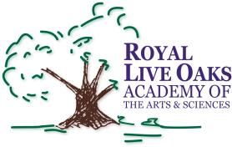 1398 Church Road, Hardeeville, SC 29927 • 843-784-2630 • www.rloacs.org

AGENDA

The Royal Live Oaks Academy of Arts & Sciences Charter School Board Meeting
April 19, 2016 6:30pm
Student Dining Hall

- Old business:

  - Approval of Minutes of March 15, 2016 meeting - Secretary

- New business:

  - RLOA Mission Statement - Chair

  - March Finance Report and Updated FY17 Budget- Bill Moser, Kelly-Moser Consulting

  - Update on New Campus Financing - Facilities Development Company

  - Resignation of Board Member Brandi Freeman

  - School Updates – Executive Director

- Public Comment

- Executive Session re Principal Evaluation Review and Discussion with Dr. Wicks

- Adjournment

